A First Project Final Report On

**ONLINE BOOK STORE**

Submitted in Partial Fulfillment of the Requirements for

The Degree of **BACHELOR OF ENGINEERING IN INFORMATION TECHNOLOGY**

Under Pokhara University

**Submitted by:**

Pradeep Chaudhary,201525

Prabin Yadav, 201551

Radha Pant,201529

Date:

3rd August 2023



C

2001

**Department of Information Technology**

**NEPAL COLLEGE OF INFORMATION TECHNOLOGY**

Balkumari, Lalitpur, Nepal

**ABSTRACT**

The Book Store Project is a comprehensive software system designed to streamline and automate the operations of a bookstore. The project aims to provide an efficient and user-friendly platform for managing various aspects of a bookstore, including inventory management, sales tracking, customer information, and online ordering.

The Book Store Project enables efficient sales tracking by recording each transaction, including the date, time, customer details, and purchased items. This information can be used to generate sales reports, analyze customer preferences, and make informed decisions about restocking or promoting certain books.

To enhance customer convenience and expand the store's reach, the project incorporates online ordering functionality. Through a secure online platform, customers can browse the book catalog, search for specific titles or authors, and place orders. The system facilitates seamless payment processing, ensuring a smooth and secure transaction experience. After an order is placed, the system generates an order confirmation for the customer's reference. Online ordering simplifies the purchasing process for customers and allows the store to cater to a wider audience beyond its physical location.

***Keywords:- html, CSS, JavaScript, php, mysql****.*

Table of Contents

**1. INTRODUCTION** 1

**1.1** **Problem Statement** 1

**1.2** **Objectives** 2

**1.3** **Scope** 3

**1.4** **Purpose** 3

**1.5** **Limitation** 3

**2. LITERATURE REVIEW** 4

**3.METHODOLOGY** 5

**3.1 SOFTWARE DEVELOPMENT LIFECYCLE** 5

3.1.1 REQUIREMENT ANALYSIS: 6

3.1.2 DESIGN PHASE: 6

3.1.3 CODING PHASE: 6

3.1.4 TESTING PHASE: 6

**3.2** **TOOLS & TECHNIQUE USED** 7

**5.ER DIAGRAM** 8

**6.USER CASE DIAGRAM** 9

**7. PROJECT DESIGN PHASE** 10

**8. PROJECT TASK & TIME SCHEDULE** 13

**9.REFERENCES** 14

**10. Appendix** 15

formation is power but the access of genuine information would be easier using the

internet. Therefore, the online bookstore will offer genuine books online in a convenient way.

Students, teachers, and other interested people should find it easy and convenient to access

knowledge. The online bookstore can greatly help them access a book they require whether for

research or learning

Information is power but the access of genuine information would be easier using the

internet. Therefore, the online bookstore will offer genuine books online in a convenient way.

Students, teachers, and other interested people should find it easy and convenient to access

knowledge. The online bookstore can greatly help them access a book they require whether for

research or learning

Information is power but the access of genuine information would be easier using the

internet. Therefore, the online bookstore will offer genuine books online in a convenient way.

Students, teachers, and other interested people should find it easy and convenient to access

knowledge. The online bookstore can greatly help them access a book they require whether for

research or learning

# **1. INTRODUCTION**

Information is power but the access of genuine information would be easier using the

internet. Therefore, the online bookstore will offer genuine books online in a convenient way.

Students, teachers, and other interested people should find it easy and convenient to access

knowledge. The online bookstore can greatly help them access a book they require whether for

research or learning

Information is power but the access of genuine information would be easier using the

internet. Therefore, the online bookstore will offer genuine books online in a convenient way.

Students, teachers, and other interested people should find it easy and convenient to access

knowledge. The online bookstore can greatly help them access a book they require whether for

research or learning

Information is power but the access of genuine Information would be easier using the internet. Therefore, the online bookstore will offer genuine books online in a convenient way. Students, teachers, and other interested people should find it easy and convenient to access knowledge. The online bookstore can greatly help them access a book they require whether for research or learning.

## **Problem Statement**

In today's digital era, traditional brick-and-mortar bookstores face significant challenges in attracting and serving customers who increasingly prefer the convenience and accessibility of online shopping. The absence of an online presence hinders bookstores from reaching a wider audience, offering a seamless purchasing experience, and effectively managing their inventory. Therefore, the problem at hand is the need to develop an online bookstore platform that addresses these challenges and provides a compelling solution for both customers and store owners.

* Physical bookstores are confined to a specific location, limiting their reach to a local customer base.
* Customers face difficulties in finding specific books in physical stores, and the process of purchasing involves time-consuming tasks like physically visiting the store and browsing through shelves.
* Physical bookstores have limited space, making it challenging to stock a vast range of titles and genres.
* Traditional bookstores typically lack the ability to offer personalized recommendations based on customer preferences, limiting the discovery of new books and potentially hindering customer satisfaction.

## **Objectives**

To solve the drawbacks of the previous system stated in problem statement section 1.1, the system (project) needed and it is important to evolve.

* The primary objective of the project is to establish an online bookstore platform that enables the store to reach a wider audience beyond its physical location.
* To develop and improve online stores to tap into the growing e-commerce market.
* This bookstore features advanced search options, intuitive navigation, user-friendly shopping cart functionality, and secure online transactions.
* To stay up-to-date with book industry trends, customer preferences, and emerging market demands to continually update books.

## **Scope**

The main scope deliverables of the project would be to:

* To provide users to purchase book online.
* To provide great discount over purchasing, reduce user’s searching time.
* To provide user friendly environment.
* To provide a wide collection of book ranges.
* Manage all the account details such as username, phone numbers, address, websites, email addresses of the entire customer from one central location.

## **Purpose**

The purpose of an online shopping system would be to achieve the following goals:

* Create a web user interface for adding, viewing, and deleting records in different areas.
* Create a user interface for inputting computer details.
* Provide a user interface for changing computer and accessory details.
* Provide a user interface that allows users to browse the store and select things to purchase.

## **Limitation**

* The application is not responsible for any scam or fraud that can occur through the use of the application.
* No direct communication between Admin and Users via platform itself.
* Platform lacks payment system for books. only cash on delivery time is accepted.

# **2. LITERATURE REVIEW**

Book store management is designed to deal with customer queries regarding information about different types of books. This is an online System that matches the customer queries regarding the author, publishers, title, price, latest updates, storage information, upgrades etc. against the information stored in the centralized database. Improved customer satisfaction by reducing the need for customers to fill out forms and provide information about their book to customer service representatives during the check-in process. The representatives can more quickly access the book history and suggest which periodic maintenance services should be performed. They can also determine what parts are in stock for the various publications, which helps customer service representatives keep customers informed about their queries while respecting their time. This improved level of service results in higher customer loyalty. The customers of today are not only attracted because online shopping is very convenient, but also because they have broader selections, highly competitive prices, better information about the product (including people’s reviews) and extremely simplified navigation for searching regarding the product. Moreover, business owners often offer online shopping options at low rates because the overhead expenses in opening and running a physical store are higher. Further, with online shopping, their products have access to a worldwide market, which increases the number of customers from different ethnic groups, adds customer value, and overall sustainable in the marketing. To develop an easy-to-use web based interface where users can search for products, view a complete description of the products and order the products. A search engine that provides an easy and convenient way to search for products specific to their needs. The search engine would list a set of products based on the search term and the user can further filter the list based on various parameters.

Based on literature reviews and web site reviews of other universities. This research was undertaken to provide background for the SCONUL and Jisc eBook Co-Design Project. Since the 1980's, when e-books first The idea of this review paper, begins from writer's disappointment about online bookstore service quality in. Indonesia. Which is, as a consumer in several transactions with the online bookstore. In overall, the writer's did not satisfied towards their services. Lions Villa Probation Hostel Gate Pass Management System at Coimbatore Campus Amrita The computerized Gate Pass Management System 27 Sep 2017. Also includes introduction to met analysis. Relevant to students from any discipline. Includes contributions from both a librarian and professor.

# **3.METHODOLOGY**

We have planned to work following these methodologies for the application of knowledge, skills, and technique to broad range of activities in order to meet the requirement of our project.

## **3.1 SOFTWARE DEVELOPMENT LIFECYCLE**

The framework we will be using for developing this project is an iterative model of software development life cycle. In this model, a simple and primitive implementation of very small set of software requirement is done at first, which is followed by the iterative enhancement in the primitive model until all requirements are fulfilled and the software is ready for deployed. The following sub section briefly describes various phase in iterative model of SDLC that was applied in the development of system.

**Figure 1: Iterative model of software development life cycle**

Figure 1: Iterative model of software development life cycle

**Figure 2: Illustration of SDLC**

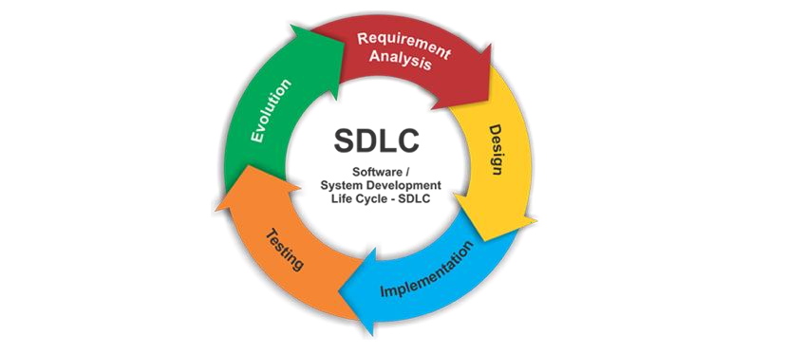

### 3.1.1 REQUIREMENT ANALYSIS:

In this phase, analysis will be performed to find out the requirements of the system. The outcome of this phase would be a SRS which is an acronym for “system requirement specifications”

### 3.1.2 DESIGN PHASE:

In this phase the SRS would be translated into the system design. Context diagram DFD ED diagram, use case diagram, sequence diagram and class diagram will be developed.

### 3.1.3 CODING PHASE:

In this phase coding will be done according for the design and a working system will be developed by the end of the process.

### 3.1.4 TESTING PHASE:

In this phase the system will be tested with each testing list of changes to the system developed, is suggested and the change will be applied to the software and the software would be delivered as a successive increment until a satisfying system is achieved.

## **3.2** **TOOLS & TECHNIQUE USED**

**1. HTML:** Hypertext Markup Language is the standard markup language for documents designed to be displayed in a web browser. It can be assisted by technologies such as Cascading Style Sheets (CSS) and scripting languages such as JavaScript. Web browsers receive HTML documents from a web server or from local storage and render the documents into multimedia web pages. HTML describes the structure of a web page semantically and originally included cues for the appearance of the document.

**2. CSS:** Cascading Style Sheets is a style sheet language used for describing the presentation of a document written in a markup language like HTML. CSS is a cornerstone technology of the World Wide Web, alongside HTML and JavaScript.CSS is designed to enable the separation of presentation and content, including layout, colors, and fonts. This separation can improve content accessibility, provide more flexibility and control in the specification of presentation characteristics, enable multiple web pages to share formatting by specifying the relevant CSS in a separate .css file, and reduce complexity and repetition in the structural content.

**3. PHP:** PHP is a recursive acronym for "PHP: Hypertext Pre-processor". PHP is a server side scripting language that is embedded in HTML. It is used to manage dynamic content, databases, session tracking, even build entire ecommerce sites. It is integrated with a number of popular databases, including MySQL, PostgreSQL, Oracle, Sybase, Informix, and Microsoft SQL Server PHP supports a large number of major protocols such as POP3, IMAP, and LDAP. PHP4 added support for Java and distributed object architectures (COM and CORBA), making n-tier development a possibility for the first time.

**4. PhpMyAdmin:** phpMyAdmin is a free and open-source administration tool for MySQL and Maria DB. As a portable web application written primarily in PHP, it has become one of the most popular MySQL administration tools, especially for web hosting services. Domains of phpMyAdmin:

**5. JavaScript:** JavaScript is a popular programming language used primarily for web development. It is a versatile, high-level, and interpreted language that allows developers to add interactive and dynamic elements to websites.

# **5.ER DIAGRAM**

Buy/Purchase

User Proceed

Adds

Manages

Views

Cart

Tracking

Products

Admin

Customer

Login/Register

Online Book Store

Views

**Figure 3 : ER Diagram of Online Book Store**

# **6.USER CASE DIAGRAM**

**Figure 4 : User Case diagram of Online Book Store**

Admin

# **7. PROJECT DESIGN PHASE**

**Figure 6: 0 level data flow diagram**

**Figure 7: Data Flow Diagram for Admin Process**

# 

**Figure 8: Data Flow Diagram for Registration process and profile update**

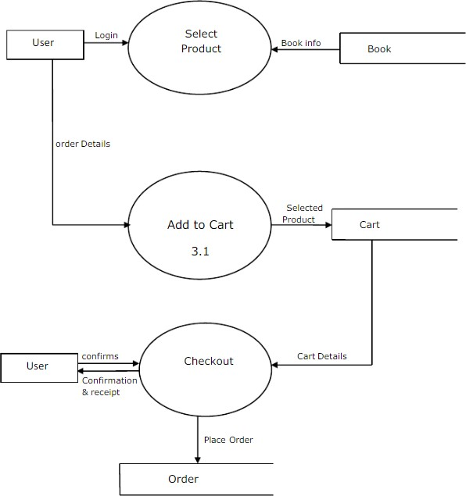

**Figure 9: Data Flow Diagram for Shopping and Checkout process**

# **8. PROJECT TASK & TIME SCHEDULE**

|  |  |  |  |  |
| --- | --- | --- | --- | --- |
|  | **July** | | | |
| Weeks | 1st week | 2nd week | 3rd week | 4th week |
| Requirement Gathering |  |  |  |  |
| Analysis |  |  |  |  |
| Design |  |  |  |  |
| Coding |  |  |  |  |
| Testing |  |  |  |  |
| Implement |  |  |  |  |

|  |  |  |  |
| --- | --- | --- | --- |
| Task / Person | Pradeep | Prabin | Radha |
| Requirement analysis and planning | ✓ | ✓ | ✓ |
| Design and Styling | ✓ | ✓ | ✓ |
| Frontend Coding | ✓ | ✓ | ✓ |
| Backend Implementation | ✓ |  |  |
| Documentation | ✓ |  |  |

# **9.REFERENCES**

1. <https://www.google.com/>
2. <https://www.freeprojectz.com/dfd/online-book-store-dataflow-diagram>
3. <https://myrepublica.nagariknetwork.com/news/bookstores-in-nepal-the-past-the-present-and-the-future/>
4. <https://www.wikipedia.org/>
5. <https://www.docsity.com/en/project-proposal-of-an-online-bookstore/8000343/>
6. Mr. WebDesigner Anas

# **10. Appendix**

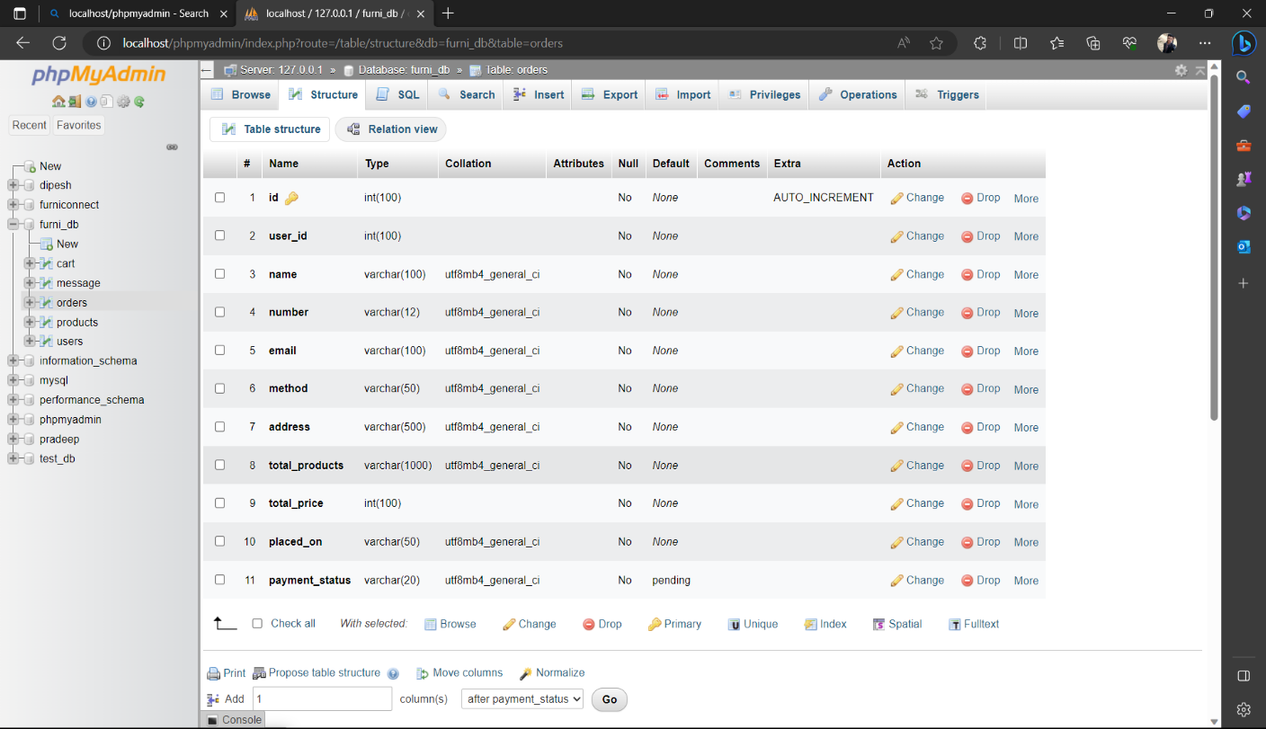

**Figure 10: Database overview**

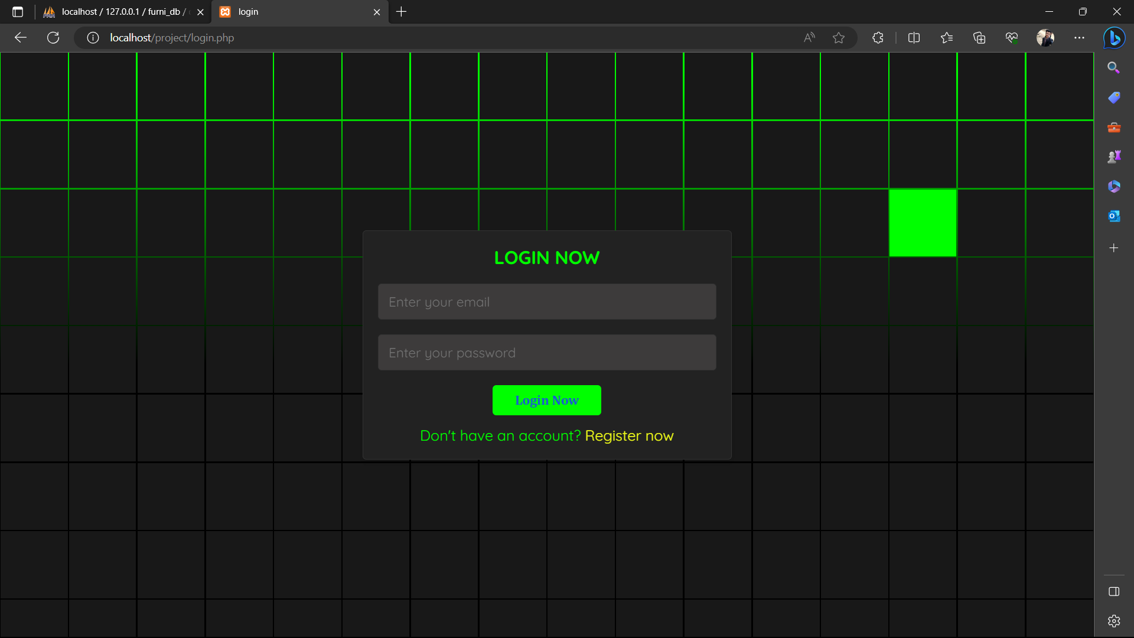

**Figure 11: Login page**

**Figure 12: Registration page**

**Figure 13: Admin home_page**

**Figure 14: User home_page**